Project A: Spinning Combination of Plane & Fish

Yiming Dai YDF9097

* **User’s Guide**

The goals of the project are as follows:

First, make a collection of several obviously-different, visually-distinctive rigid 3D ‘parts’ stored sequentially on the GPU. For each ‘part’, there is a fixed set of colorful vertices define a closed 3D shape.

Second, assemble ‘3D parts’ to make several kinds of animated, jointed 3D ‘objects’. These objects move independently. Each ‘object’ consists of several ‘parts’ connected only by fixed or hinged joints.

Third, add some interactive animations. By doing so, these jointed objects then moves dramatically, smoothly, and continuously without any user input (animation), but also respond to users’ mouse & keyboard input and GUI.

* **User’s instructions**

When opening the html file in web browser, there will be 5 parts shown on the web page. All parts are isolated by a gray border.

1. The first part is title of the project and author’s name and NetID.

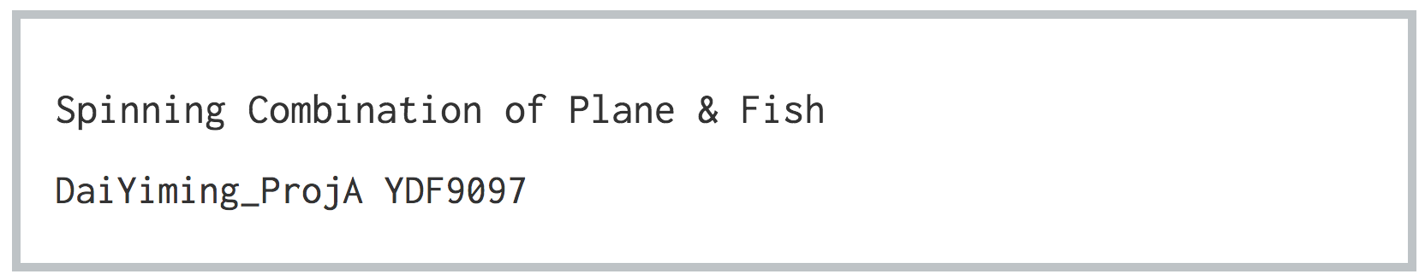

Figure 1 Title of the Project and Author’s Name and NetID

1. The second part shows the movement situation of the Plane part. For example, when you stop the spinning, there will be a sentence of ‘The plane stops!!’ showing on this part. When the Plane part spins normally, there will be objects’ spinning speed showing on this part.

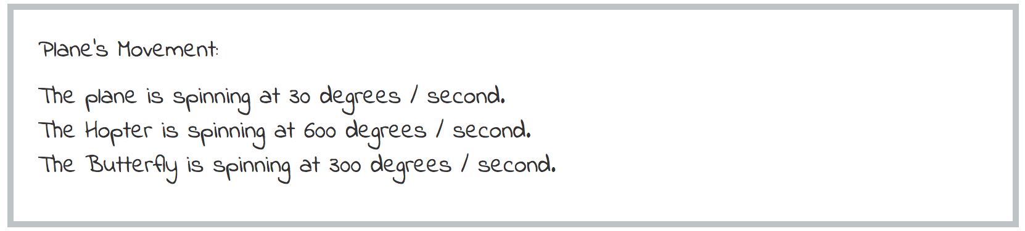

Figure 2 Movement Situation of the Plane Part

1. The third part shows the location of the Fish part. If you use mouse to drag the Fish part to other places in canvas, there will be ‘x’ and ‘y’ coordinates shown on this part.

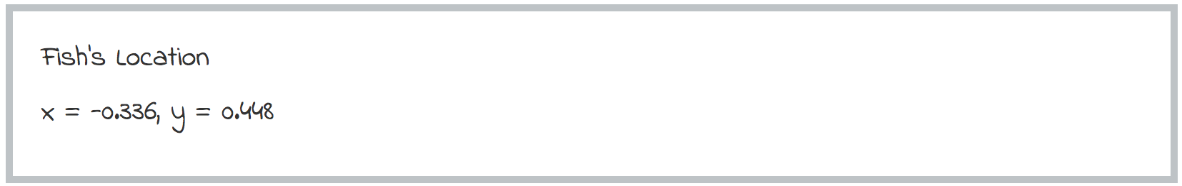

Figure 3 Fish’s Location

1. The fourth part is the ‘instructions’ part. By pressing the ‘paw’ button, the instructions will be shown as below. Instructions are as follows:

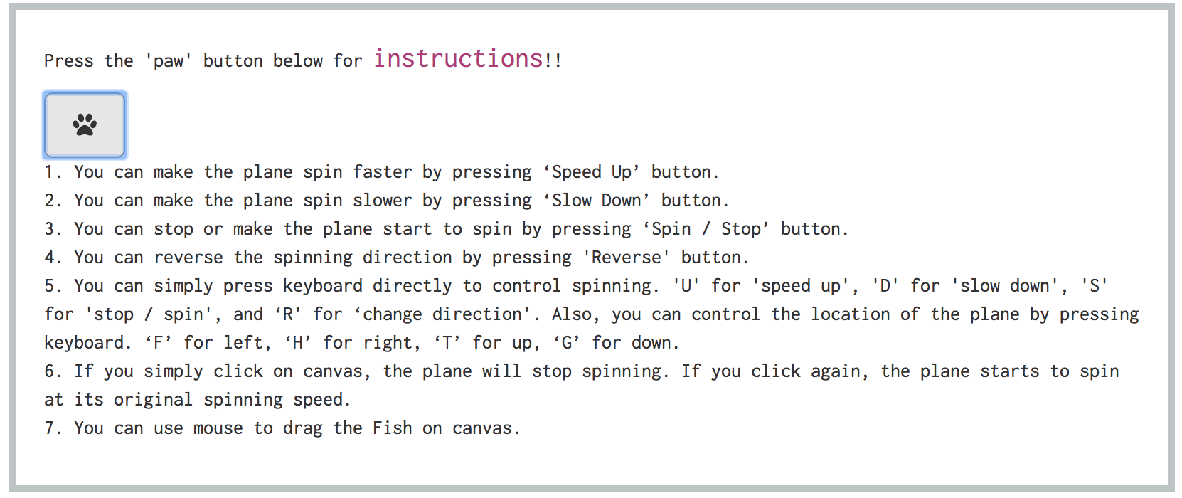

Figure 4 Instruction Part

1. The fifth part is the ‘canvas’ where you can see a spinning combination of plane with a hopter on its head and an icosahedron behind its tail. There is also a spinning combination of a fish and two spinning tops on right upper corner of canvas. By following instructions, you can control movements of these objects.

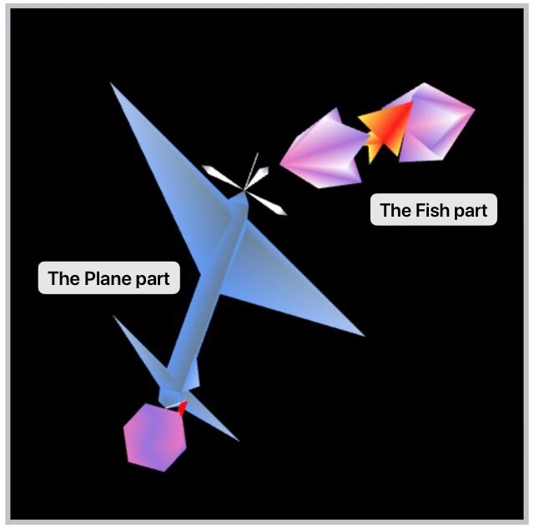

Figure 5 Canvas

1. The sixth part is a Control Panel with some buttons. By following the instructions in the third part, you can simply use mouse to press these buttons to control movement of the Plane part.

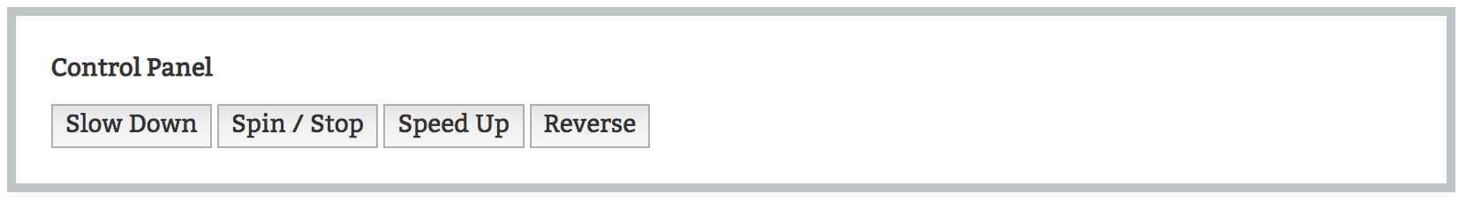

Figure 6 Control Panel

* **Results**

Below are pictures of the project’s results.

As we can see from Figure 5, it shows original locations of the Plane part and the Fish part.

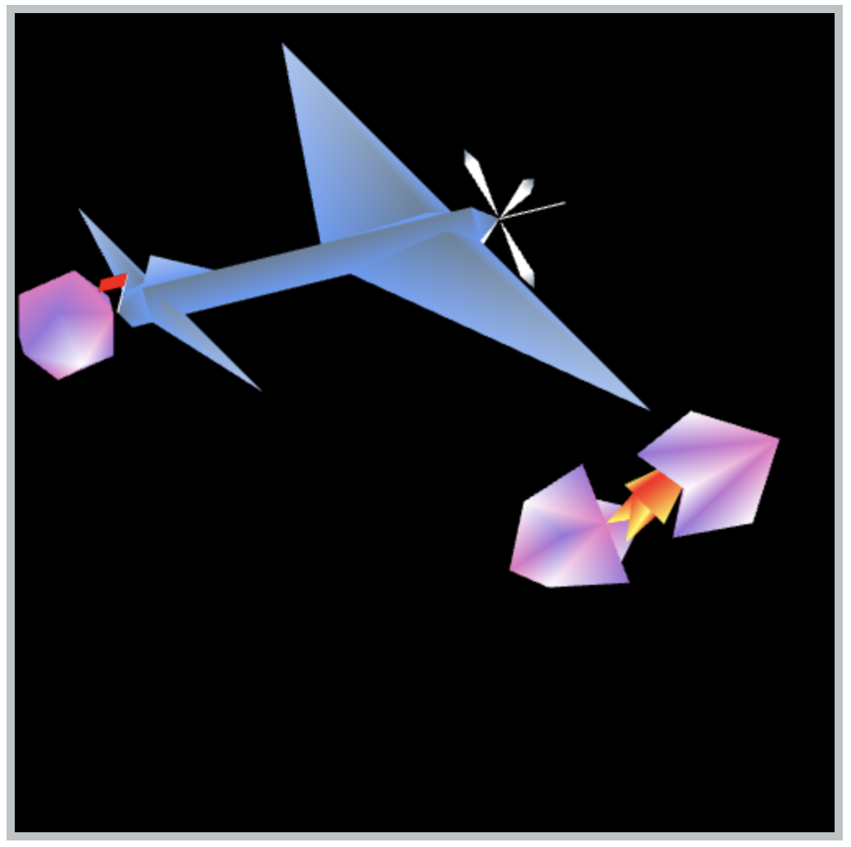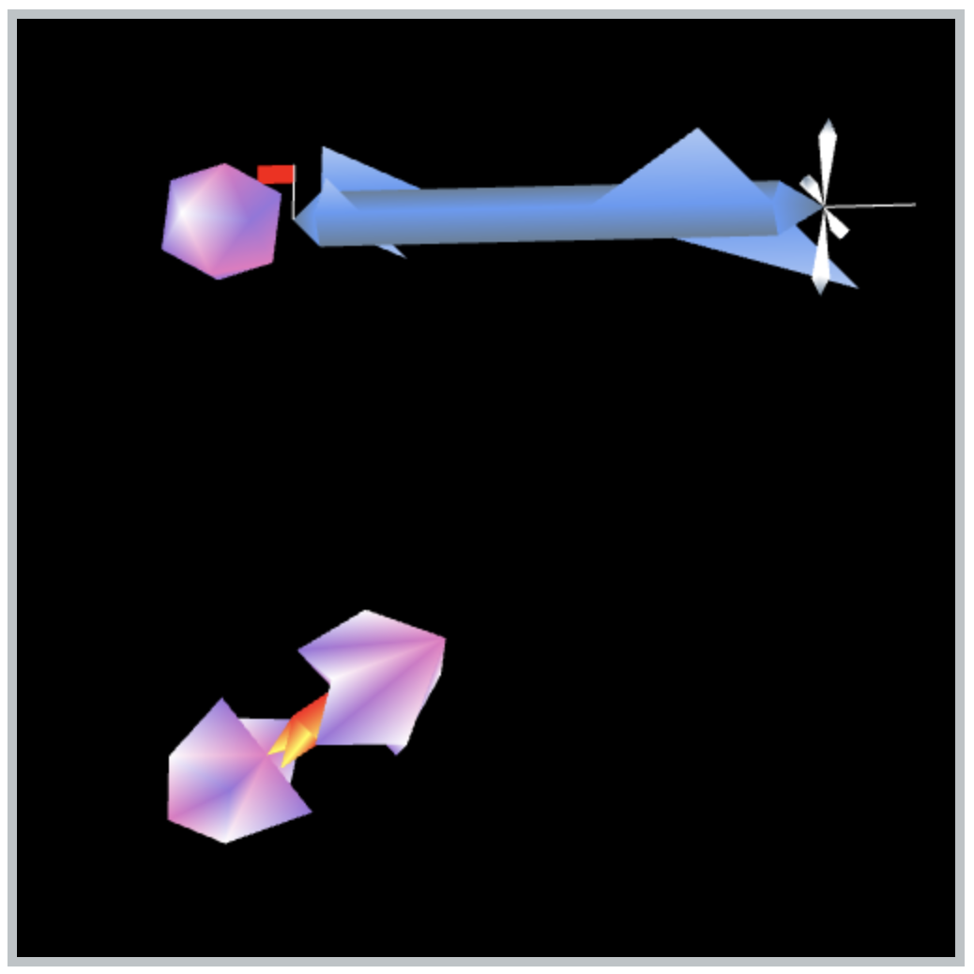

Figure 7 When Moving the Plane Part and the Fish Part

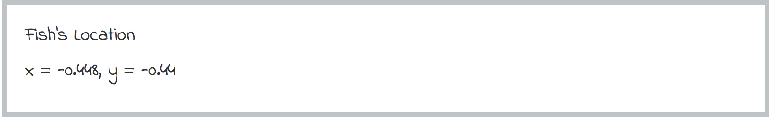

Figure 8 Fish’s Location

As we can see from Figure 7, when we drag the Fish part to another location on canvas using mouse, the Fish part will be on any location we drag it to. Figure 8 shows Fish’s location on canvas. And we can also move the Plane part by pressing keyboard to any location on the canvas.

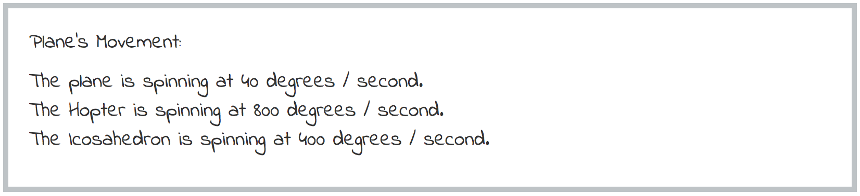

Figure 9 the Plane Part's Spinning Speed

When controlling the Plane part’s spinning speed, the result will be shown on web page as Figure 9 shows.

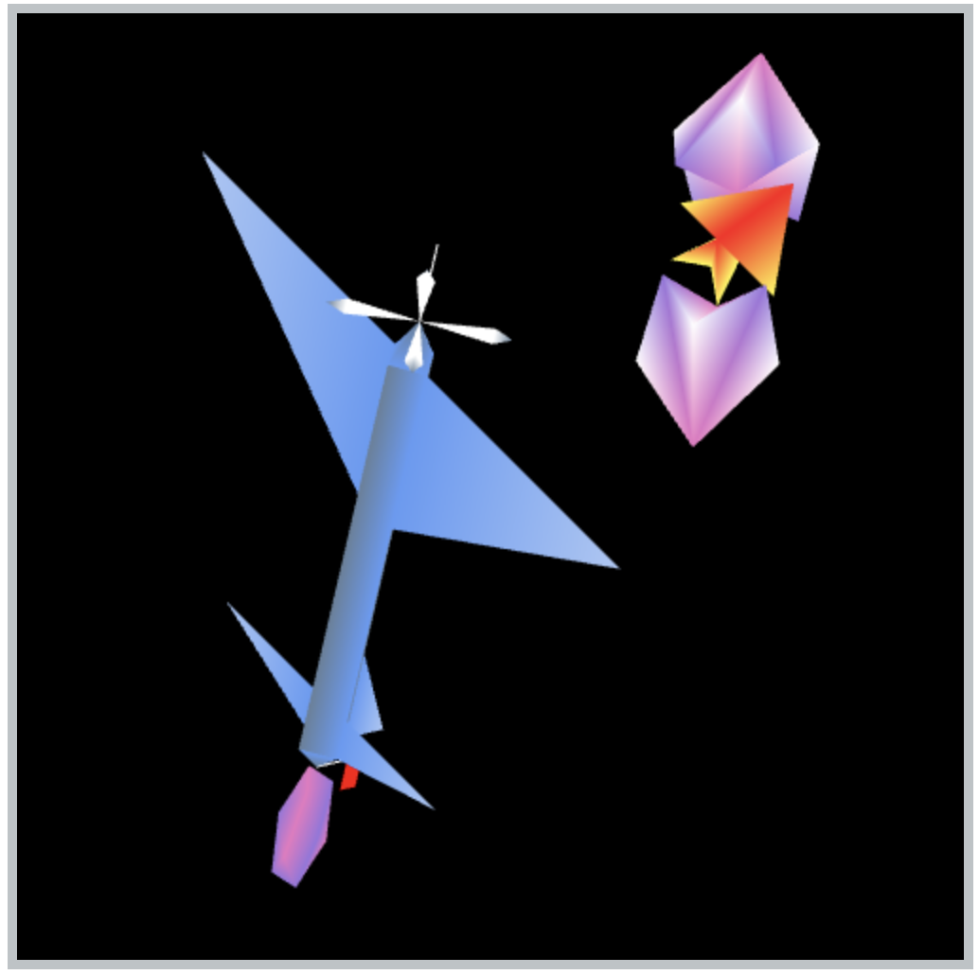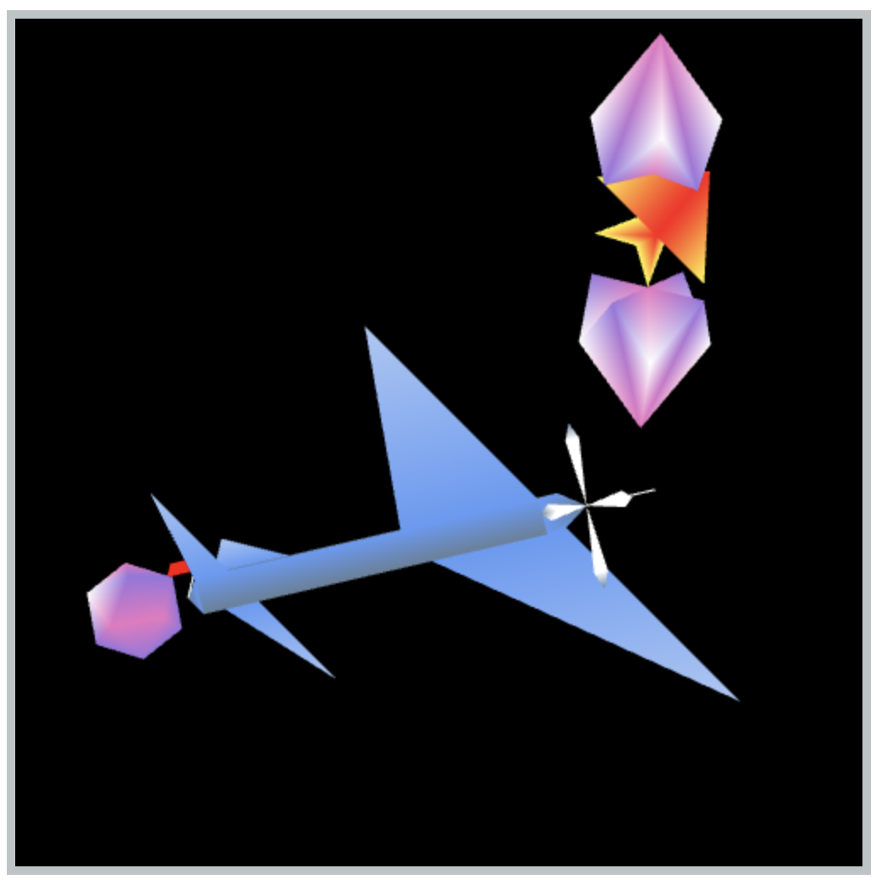

Figure 10 Icosahedron Shape Changes

Figure 10 shows that the icosahedron, which locates behind the tail of the plane, changes its shape from regular pentagon to icosahedron, then it changes from icosahedron to regular pentagon, over and over again.

* **Scene Graph**

Figure 11 shows a scene graph diagram of the project. The nodes labeled with T mean a matrix translation. Those labeled with R mean a matrix rotation. Some have T, R which means a translation then rotation.

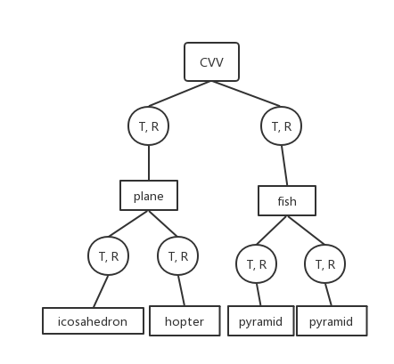

Figure 11 Scene Graph of the Project